STANDARD 8

Requirements:

LCRNS.3.0130 LANS Service Geometric Dilution of Precision (GDOP)

The Lunar Relay Service shall provide LANS services with Geometric Dilution of

Precision (GDOP) <6 (TBR) in the Service Volumes identified in Table 3-3.

LCRNS.3.0240 EVA surface initial Operations Duration

The Lunar Relay Service shall provide navigation services such that the NASA human spaceflight architecture on the lunar surface can meet a minimum of 24 hours of cumulative surface EVA time per crewmember per 7 Earth-day period during surface stays greater than or equal to 14 Earth-days.

LCRNS.3.0570 Position, Navigation, and Timing – User

The Lunar Relay Service shall provide PNT services such that user PNT performance (TBR) listed in Table 3‑10 are met, specified in a lunar-centric inertial frame.

LCRNS.3.0600 Position, Navigation, and Timing – (Service Reference Signals)

The Lunar Relay Service shall provide signals with SISE contributions as specific in Table 3-11 or better.

**Finding**: Based on Government in‐house analyses, the described system does not adequately demonstrate compliance with the required GDOP <6 coverage over 40% of each Earth Day.

**Finding**: Proposal does not adequately describe how compliance with LCRNS.3.0130 LANS Service GDOP is achieved, especially for IOC‐C.

**Finding**: Government analyses related to LCRNS.3.0240 EVA Surface Initial Operations Duration show continuous coverage gaps every 4‐6 days‐step in 30 days cycle. Proposal does not adequately describe how compliance is achieved.

IM WRITTEN RESPONSE:

The IM/Raytheon team is in the process of updating the satellite constellation models based on this

feedback from the government.

The constellation shown in Figure 1 shows the configuration of the proposed system across IOC phases.

The constellation consists of two satellites in highly elliptical frozen orbits, Khon‐3 and Khon‐4 in ELFO 1

and ELFO2 respectively, and two satellites in halo orbits at the earth moon Lagrange points, Khon‐5 and

Khon‐6 in EML1 and EML2. The periods of the highly elliptical frozen orbits are 29 hours. The period of

the EML1 halo is 12 days and the EML2 halo is 14.5 days. These two orbits will sync over the south pole

every 69.6 days.

We note that two highly elliptical frozen lunar orbit satellites in ELFO1 and ELFO2 orbits sharing a single

apolune above the south pole and spend 91% of their 29‐hour orbits at altitudes sufficient to cover the

south pole. These satellites spend 2.5 hours out of view of the south pole per 29‐hour orbit. This gives us

81% of the orbit where both ELO satellites are above the horizon.

We also note that all these coverage percentages increase at the top of the 200 km high zone bounding

the service volumes.

The Final Proposal Revision will provide clear descriptions of how the proposed service achieves

compliance with the standards in these findings. Please note the responses to individual findings below.

The IM team performed additional analysis with the Georgia Tech Space Systems Design Laboratory to

refine the operational metrics for the Khon network. Our simulations in Figure 3 for GDOP coverage

indicate that we can meet the GDOP <6 coverage requirement with six satellites. On average we have 4

of 6 in view at one time within the LSP coverage zone, but there are times that that drops down to 2

where the GDOP increases.

*Figure 1 ‐‐ Satellite Network Configurations Through IOC‐C*

However, the Khon1 satellite does not provide PNT services. Excluding Khon1 from coverage, our

simulations in Figure 2 show that we can definitively meet GDOP <6 requirements through IOC‐B in the

current configuration. At IOC‐C, the percent of time that GDOP is <6 at all points within the service volume simultaneously is only 23%. Each point within the service volume still has GDOP <6 for at least

50% of the day, though, so we believe this is still compliant with the requirement. The IM team will

perform optimizations of the Khon2‐6 orbits for the FPR to explore potential performance

improvements beyond the current offering. Updated calculations will be presented in oral discussions

and the FPR.

*Figure 3 ‐ Simulated GDOP Coverage at Lunar South Pole for Six Satellites*

*Figure 2 ‐ GDOP <6 Coverage for IOC‐A/B/C*

At the beginning of the lunar day, the system provides initial coverage windows of 7.2 days for four SVs

and 9.5 days for three SVs (with TWTR). During this period, there are only gaps in PNT coverage of 2.5

hours every 29 hours due to the ELO satellites. After those high visibility periods, there is a 4‐day gap for

3SVs (with TWTR) in‐view and a 7 day gap for 4‐SVs in view. Before the beginning of lunar night, there is

another coverage window of 5.25‐earth days for four SVs and 10 days for three SVs. This supports the

PNT services requirement of supporting at least two lunar surface EVAs lasting at least 4 hours nominally

plus 1 hour contingency.

IM CURRENT RESPONSE:

The constellation shown in Figure 1 shows the configuration of the proposed system across IOC phases.

The constellation consists of five fully compliant PNT satellites in three planes of highly elliptical frozen orbits (ELFO), Khon‐2 and Khon‐4 are grouped in one ELFO plane, Khon-3, Khon-5, and Khon-6 are in separate ELFO planes that are arranged to provide reliable coverage and geometric diversity during the lunar month. The constellation configuration has been refined since the initial proposal to both minimize the overall Delta-V budget and to ensure GDOP coverage across the service volume for each Earth day during the lunar month. The periods of the highly elliptical frozen orbits are 29 hours. These satellites spend 2.5 hours out of view of the south pole per 29‐hour orbit. This gives 81% of the orbit where both ELFO satellites are above the horizon. We also note that all these coverage percentages increase at the top of the 200 km high zone bounding the service volumes. Table 1 provides the full Cartesian state for each satellite in the constellation in a Moon centered J2000 inertial reference frame for a common epoch at Feb 1, 2027 0:00 UTC.

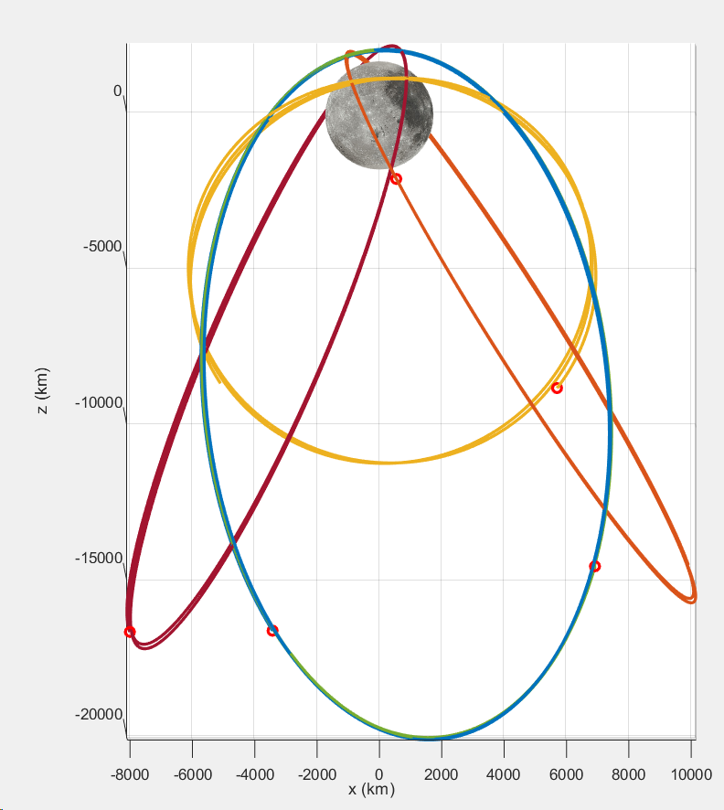

Figure 1: Khon-2 thru Khon-6 Elliptical Frozen Orbit Constellation

|  |  |  |  |  |  |  |
| --- | --- | --- | --- | --- | --- | --- |
|  | Rx (km) | Ry (km) | Rz (km) | Vx (km/s) | Vy (km/s) | Vz (km/s) |
| Khon-2 |  |  |  |  |  |  |
| Khon-3 |  |  |  |  |  |  |
| Khon-4 |  |  |  |  |  |  |
| Khon-5 |  |  |  |  |  |  |
| Khon-6 |  |  |  |  |  |  |

Table 1: Khon-2 thru Khon-6 ELFO States

wrt Moon Centered J2000 Inertial Reference Frame at Feb 1, 2027 0:00 UTC

A simulation of the Khon 2-6 ELFO constellation trajectory was conducted for a period starting from the initial reference epoch given in Table 1. The satellite orbits are model with N-body gravity for the Sun, Earth, and using the GRAIL GRGM1200B 100x100 degree and order gravity model for the Moon. Figure 2 shows the orbit geometry over a 1-year period from the initial reference epoch with no station-keeping, demonstrating that the orbits are inherently stable and require minimal station-keeping to remain in these respective orbits during the service interval.

Figure 2: Khon-2 thru Khon-6 Elliptical Frozen Orbit Constellation

1-Year Propagation with no Station-Keeping

The IM team performed additional analysis with the Georgia Tech Space Systems Design Laboratory to

refine the operational metrics for the Khon network. The orbit configuration was refined to provide GDOP coverage for each day within the lunar month. On average we have 4 of 5 in view at one time within the LSP coverage zone, but there are times that that drops down to 3 where the GDOP increases. The average GDOP for a lunar South Pole user is 4.3 over the lunar month.

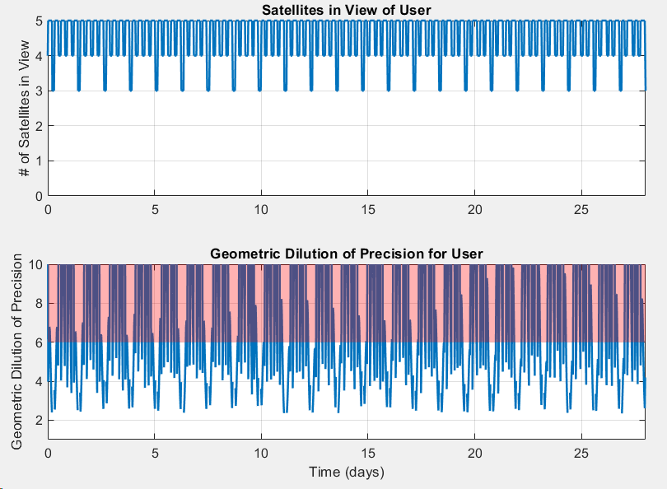

Figure 3: No of Satellites within Line of Site and GDOP Coverage for a Lunar Month

GDOP coverage in this configuration shown in Figure 4 was determined to range from 20%-35% for the worst-case Earth day within the lunar month, for any fixed location within the service volume. The arrangement is effective at minimizing gaps across the worst case coverage day, so that 1- 3 opportunities for 5 hour EVA’s are possible each day as shown in Figure 5. However, it was determined that this configuration was not capable of meeting the coverage requirements specified in LCRNS.3.0130. Other 5-satellite orbit configurations were assessed which improved the coverage overall, however the station-keeping Delta-V proved to be prohibitively large and/or gaps on the worst case Earth day always persisted.

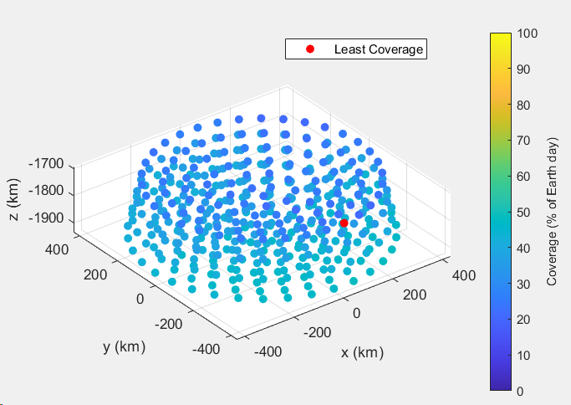

Figure 4: GDOP Coverage for the Worst Case Earth Day within the Lunar Month

for 5-satellite ELFO configuration

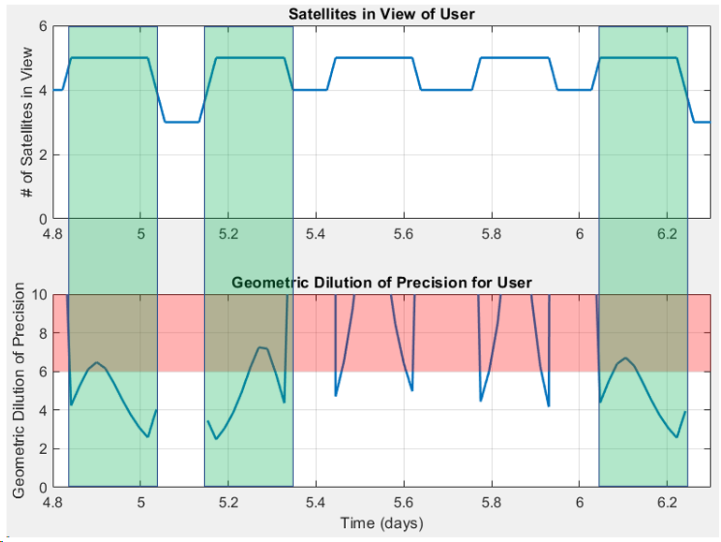

Figure 5: EVA Opportunities for the Worst Case Earth Day within the Lunar Month

for 5-satellite ELFO configuration

For these reasons, it was determined that an additional PNT asset was necessary to adequately address the GDOP coverage requirements specified in LCRNS.3.0130. An additional Khon-7 satellite, identical to Khon-2, was added the constellation in an ELFO plane with a phased offset from Khon-3. Figure 6 shows the constellation configuration for Khon2-Kohn7 ELFO geometry. Table 2 provides the full Cartesian state for the full 6-satellite PNT constellation in a Moon centered J2000 inertial reference frame for a common epoch at Feb 1, 2027 0:00 UTC.

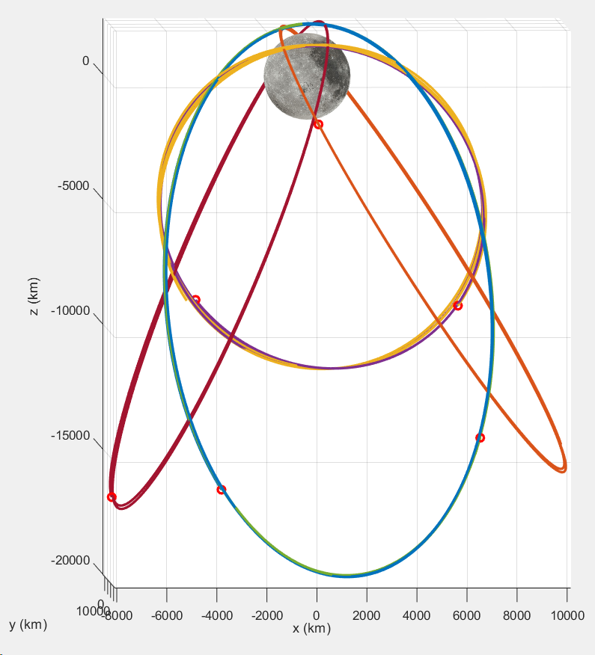

Figure 6: Khon-2 thru Khon-7 Elliptical Frozen Orbit Constellation

|  |  |  |  |  |  |  |
| --- | --- | --- | --- | --- | --- | --- |
|  | Rx (km) | Ry (km) | Rz (km) | Vx (km/s) | Vy (km/s) | Vz (km/s) |
| Khon-2 |  |  |  |  |  |  |
| Khon-3 |  |  |  |  |  |  |
| Khon-4 |  |  |  |  |  |  |
| Khon-5 |  |  |  |  |  |  |
| Khon-6 |  |  |  |  |  |  |
| Khon-7 |  |  |  |  |  |  |

Table 2: Khon-2 thru Khon-7 ELFO States

wrt Moon Centered J2000 Inertial Reference Frame at Feb 1, 2027 0:00 UTC

The 6-satllite orbit configuration provides on average 5 of 6 satellites in view at one time within the LSP coverage zone, but there are times that that drops down to 4 where the GDOP increases. The average GDOP for a lunar South Pole user is improved to 3.9 over the lunar month.

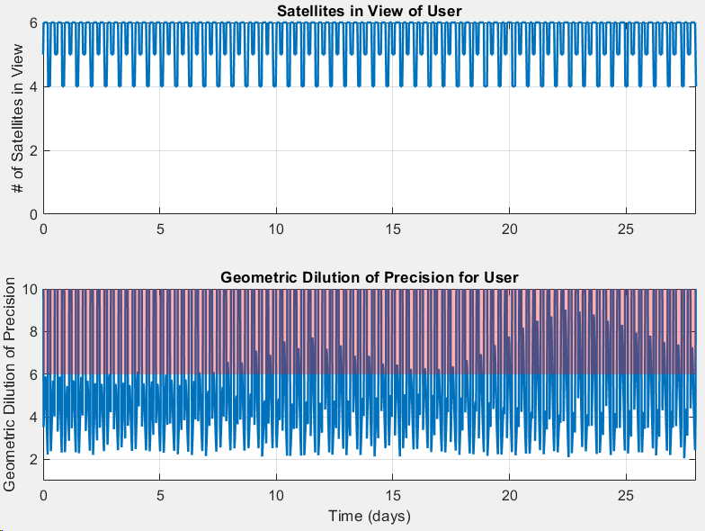

Figure 7: No of Satellites within Line of Site and GDOP Coverage for a Lunar Month

with the Final 6-satellite ELFO Configuration

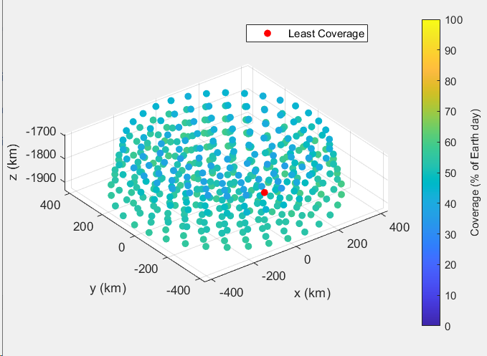

Figure 8: GDOP Coverage for the Worst Case Earth Day within the Lunar Month

for 6-satellite ELFO configuration

GDOP coverage in this final configuration is shown in Figure 8 was determined to range from 35%-65% for the worst-case Earth day within the lunar month, for any fixed location within the service volume. Figures 9 shows the opportunities to support EVA’s for a typical coverage day within this configuration; three or four 5 hour windows exist with continuous performance with GDOP<6 is generally available every Earth day. For this configuration, the worst-case coverage gaps occur on day 22. Figure 10 shows the opportunities to support EVA’s for a worst case condition. There are two 4 hour windows with continuous performance with GDOP<6, but the contingency hour specified in LCRNS.3.0240 is not supported in this worst case.

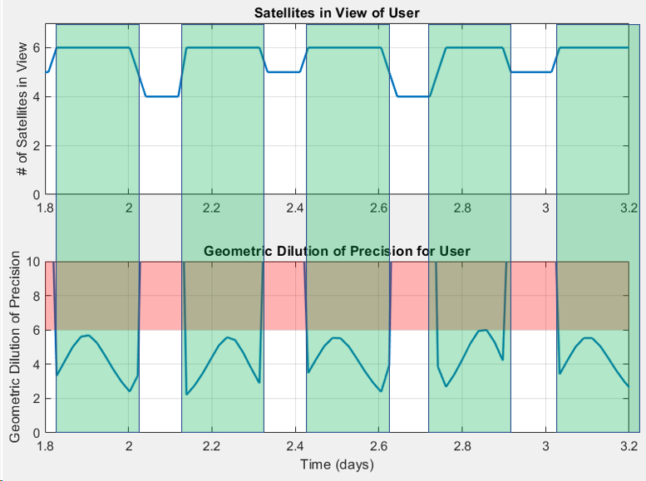

Figure 9: EVA Opportunities for the Typical Case Earth Day within the Lunar Month

for 6-satellite ELFO configuration

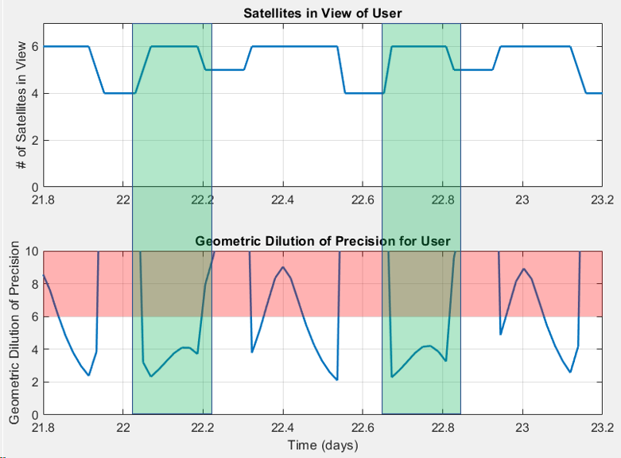

Figure 10: EVA Opportunities for the Worst Case Earth Day within the Lunar Month

for 6-satellite ELFO configuration

To address intervals where NASA operations require 40% coverage with GDOP<6 and/or multiple 5-hour EVA windows with GDOP<6 on a specific Earth day, capability does exist to adjust the phasing of the satellites in their respective ELFO’s to ensure that coverage and performance can be provide when required. Figure 11 shows an assessment of the operational delta-V needed to adjust the mean anomaly of an asset within a fixed time interval. Assuming the orbit period is adjusted at perilune, we can achieve a 90-degree mean anomaly adjustment with ~20 m/s in 48 hours, or ~50 m/s in 24 hours. Expecting that a minor mean anomaly adjustment (<< 90-degree) should be sufficient to provide the augment the configuration for ideal geometric coverage, this adjustment should be manageable with a 5-10 m/s correction -depending on the time available to make the adjustment. This supports the PNT services requirement of supporting at least two lunar surface EVAs lasting at least 4 hours nominally plus 1 hour contingency.

Figure 11: Delta-V Required to Adjust ELFO Mean Anomaly in One Orbit Revolution

PROPOSED UPDATES TO PROPOSAL CONTENT:

(LCRNS.3.0130, LCRNS.3.0240, LCRNS.3.0570 is addressed in V2/SC2.2/ExD/AttA)

**CURRENT WORDING:**

For NSNS, IM determined the optimum initial architecture consists of two LCRNS compliant satellites in each of two ELFO augmented by single satellites in Earth-Moon Lagrange 1 (EML1) and EML2.

The final two satellites (Khon5 in EML-1 and Khon6 in EML-2) are added to enable Increment C (Full IOC) by

IM adds four satellites, with one satellite each in two North pole ELFOs, and an additional satellite in EML-1 and EML-2, which meets the required lunar communication and PNT coverage.

To meet the Increment C (Full IOC) requirements, we launch two more LCRNS compliant satellites (Khon5 and Khon6) in October 2026 and insert them into EML-1 and EML-2, which ensures 24-hour, 7-day data relay and PNT coverage of the lunar South pole region.

IM provides additional S, X, and Ka-Band forward and return services and the required nodes to complete the PNT architecture with our fifth (Khon5) and sixth (Khon6) satellites that will operate in EML-1 and EML-2 beginning in January 2027 and enable validation of our Full IOC by March 2027.

Table 2.8.2-3. INCREMENT C (FULL IOC) PERFORMANCE – IM provides Full IOC by March 2027

With the addition of Khon5 (EML-1) and Khon6 (EML-2) satellites, we increase capacity for S-band and Ka-band communications while maintaining 100% communication coverage, which exceeds the 100% up to -75 degrees latitude Increment C (Full IOC) requirement (**Figure 2.9-3**).

Table 2.9-1. KHON SATELLITE CAPABILITY – IM Data Relay Satellites provide geographical diversity around the Moon that aligns with NSNS incremental phasing requirements

The satellites in the EML1 and EML2 have LOS to the south pole SV1 and SV2 roughly 60% of their 14-day orbits. This leaves gaps of coverage lasting 4.8 and 5.8 days. However, the satellites in the ELFOs have LOS to the south pole SV1 and SV2 around 80% coverage. The resulting lunar user accuracy of 48.85% coverage for the lunar surface and 68.35% for users in 200-km lunar orbits with Geometric Dilution of Precision (GDOP) <6 (**Figure 2.9-6)**, exceeds Increment C (Full IOC) requirements.

**CHANGE WORDING TO:**

For NSNS, IM determined the optimum initial architecture consists of six LCRNS compliant satellites in various ELFO orbit planes to ensure reliable coverage and geometry for the system performance.

The final three satellites (Khon5 in ELFO-3, Khon6 in ELFO-4, and finally Khon-7 in ELFO-1) are added to enable Increment C (Full IOC) by

IM adds four satellites, with one satellite each in two North pole ELFOs, and an additional satellite in EML-1 and EML-2, which meets the required lunar communication and PNT coverage. <no change?>

To meet the Increment C (Full IOC) requirements, we launch three more LCRNS compliant satellites (Khon5, Khon6, and Khon7) in October 2026 and insert them into ELFO-3, ELFO-4, and ELFO-1 respectively, which ensures 24-hour, 7-day data relay and PNT coverage of the lunar South pole region.

IM provides additional S, X, and Ka-Band forward and return services and the required nodes to complete the PNT architecture with our fifth (Khon5), sixth (Khon6), and seventh (Khon7) satellites that will operate in ELFO-3, ELFO-4, and ELFO-1 beginning in January 2027 and enable validation of our Full IOC by March 2027.

|  |  |  |
| --- | --- | --- |
| Service | Requirement | IM Capability |
| Ka-band | 2 – Forward + Return | 10 – Forward + Return |
| S-band | 2 – Forward + Return | 10 – Forward + Return |
| AFS/LANS | 4 (40% - GDOP<6) | 4-6 (35%-65% - GDOP<6) |
| Service Volume | South pole up to -75 deg; 200 km altitude | South pole up to -75 deg; 200 km altitude |
| Coverage of an Earth Day | Ka-band – 75%  S-band – 90%  AFS – 40% | Ka-band – 100%  S-band – 100%  AFS (w/LANS) – 48.85% |
| Service Availability | Nominal 95%; Critical 98% | Nominal 95%; Critical 98% |

|  |
| --- |
| Table 2.8.2-3. INCREMENT C (FULL IOC) PERFORMANCE – IM provides Full IOC by March 2027 |

|  |  |  |  |  |  |  |  |
| --- | --- | --- | --- | --- | --- | --- | --- |
|  | Khon1 | Khon2 | Khon3 | Khon4 | Khon5 | Khon6 | Khon7 |
| Launch Date/Mission | November 2023 | April 2024 | Oct 2025 | Oct 2025 | Oct 2026 | Oct 2026 |  |
| Operational Period | Feb 2024 – Jan 2029 | Jul 2024 – Jun 2029 | Jan 2026 – Dec 2030 | Jan 2026 – Dec 2030 | Jan 2027 – Dec 2031 | Jan 2027 – Dec 2031 |  |
| Relay size category |  |  |  |  |  |  |  |
| Planned orbit | ELFO 1 | ELFO 2 | ELFO 1 | ELFO 2 | ELFO 3 | ELFO 4 | ELFO 1 |
| Communication Functional and performance specifications | Forward: S-band  Return: S-band  TT&C/Uplink: S-band  Downlink: X-band | Forward: S/X-band  Return: S/X/Ka-band  TT&C/Uplink: S/X-band  Downlink: S/X/Ka-band | Forward: S/X-band  Return: S/X/Ka-band  TT&C/Uplink: S/X-band  Downlink: S/X/Ka-band | Forward: S/X-band  Return: S/X/Ka-band  TT&C/Uplink: S/X-band  Downlink: S/X/Ka-band | Forward: S/X-band  Return: S/X/Ka-band  TT&C/Uplink: S/X-band  Downlink: S/X/Ka-band | Forward: S/X-band  Return: S/X/Ka-band  TT&C/Uplink: S/X-band  Downlink: S/X/Ka-band |  |
| EIRP (Max) | S-band: 36 dBW | S-band: 36 dBW  Ka-band: 55 dBW | S-band: 36 dBW  Ka-band: 55 dBW | S-band: 36 dBW  Ka-band: 55 dBW | S-band: 36 dBW  Ka-band: 55 dBW | S-band: 36 dBW  Ka-band: 55 dBW |  |
| G/T (Max) | S-band: -1 dB/K | S-band: -1 dB/K  Ka-band: 21 dB/K | S-band: -1 dB/K  Ka-band: 21 dB/K | S-band: -1 dB/K  Ka-band: 21 dB/K | S-band: -1 dB/K  Ka-band: 21 dB/K | S-band: -1 dB/K  Ka-band: 21 dB/K |  |
| Navigation functional and performance specifications | N/A | 2-Way Radiometrics (Range/Doppler) | | | 2-Way Radiometrics (Range/Doppler)  LunaNet LANS One-Way PNT | | 2-Way Radiometrics (Range/Doppler) |
| Simultaneous Links supportability | 1 S Fwd and Ret | 2 Ka Fwd and Ret  2 S Fwd and Ret  1 X Fwd and Ret  AFS/LANS | 2 Ka Fwd and Ret  2 S Fwd and Ret  1 X Fwd and Ret  AFS/LANS | 2 Ka Fwd and Ret  2 S Fwd and Ret  1 X Fwd and Ret  AFS/LANS | 2 Ka Fwd and Ret  2 S Fwd and Ret  1 X Fwd and Ret  AFS/LANS | 2 Ka Fwd and Ret  2 S Fwd and Ret  1 X Fwd and Ret  AFS/LANS |  |
| Other similar or relevant characteristics | Network Precursor | Full LCRNS Compliance and Capability  Additional simultaneous S-Band Links when using S-Band Multiple Access | | | | |  |
| Table 2.9-1. KHON SATELLITE CAPABILITY – IM Data Relay Satellites provide geographical diversity around the Moon that aligns with NSNS incremental phasing requirements | | | | | | |  |